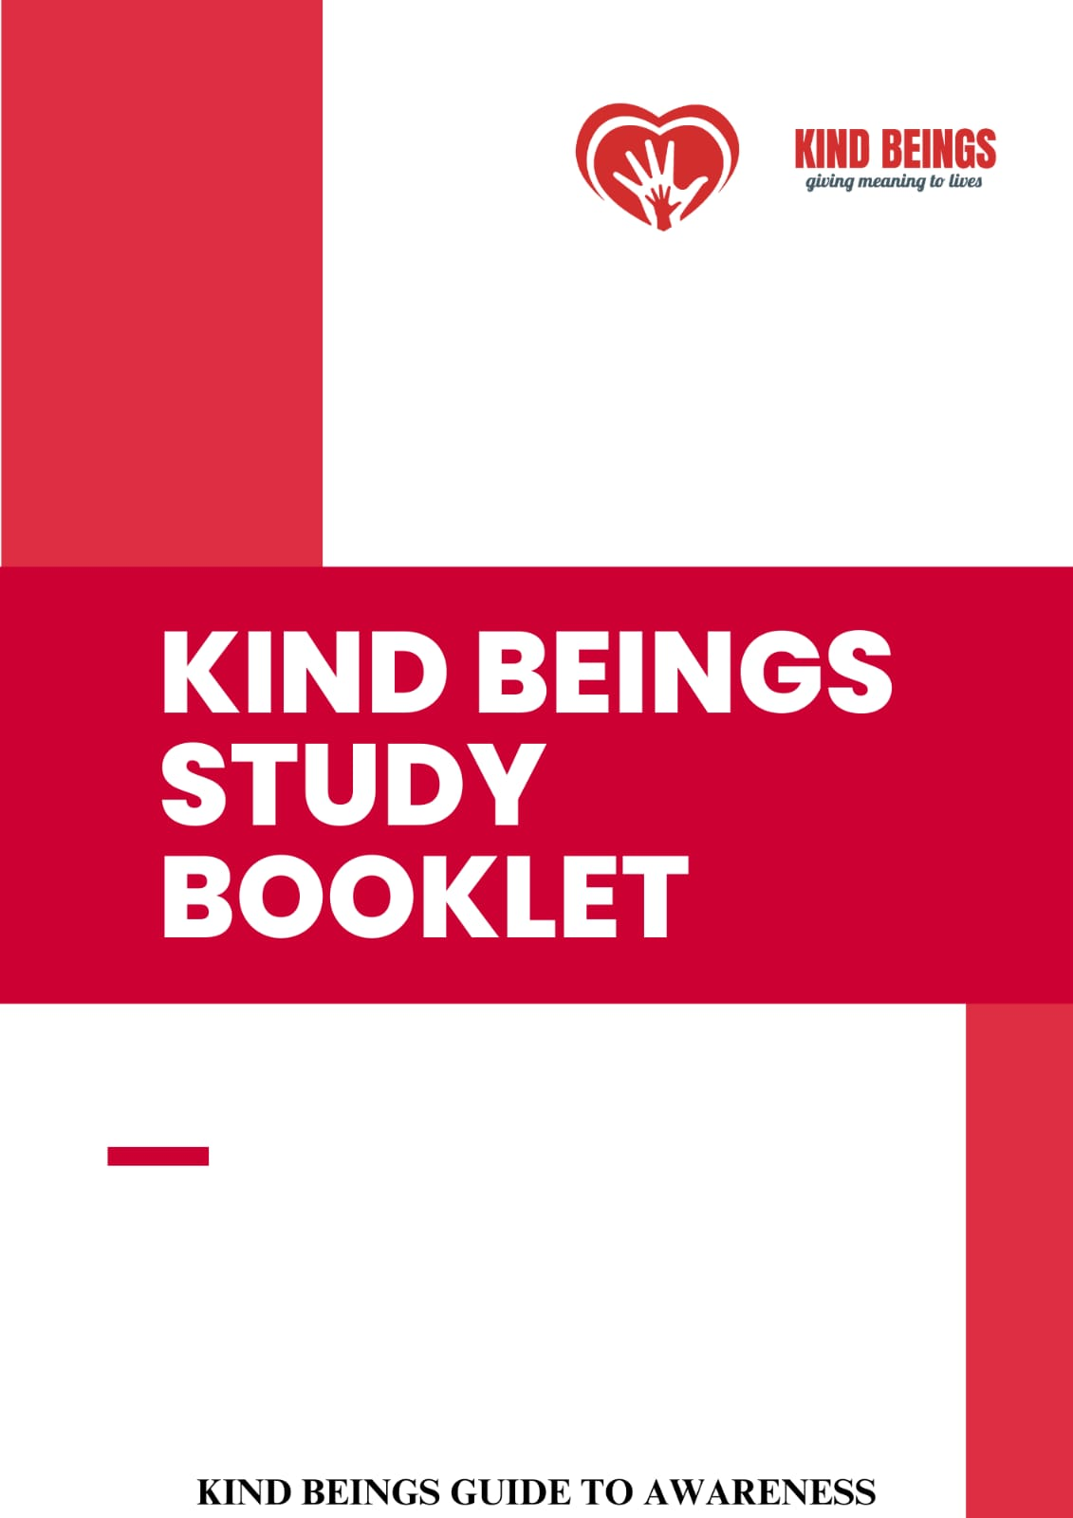

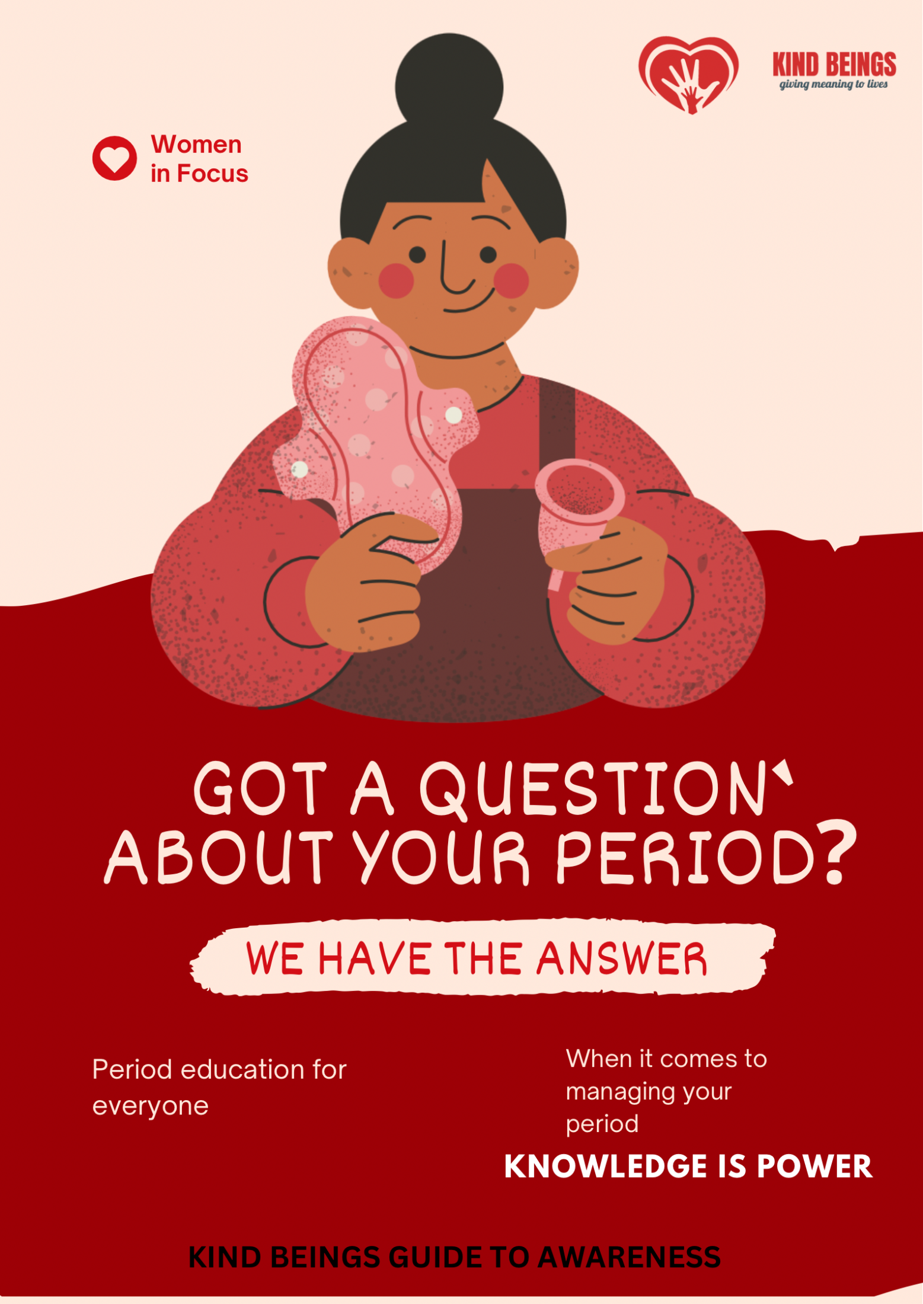

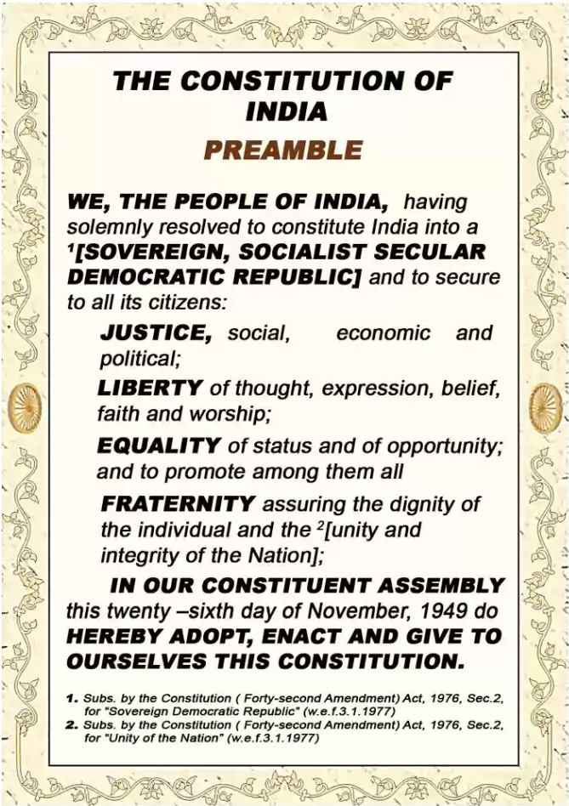

**KIND BEINGS NGO**

Kind Beings, a government-registered organisation from New Delhi, India, began in December 2018. We are a group of young professionals who joined in carrying out 'Acts of Kindness' to bring about a unified societal shift.

Through numerous strategies, we work to give lives a purpose.

We are also acknowledged as the Delhi NGO with the fastest growth rate. We have increased our presence manifold in several states.

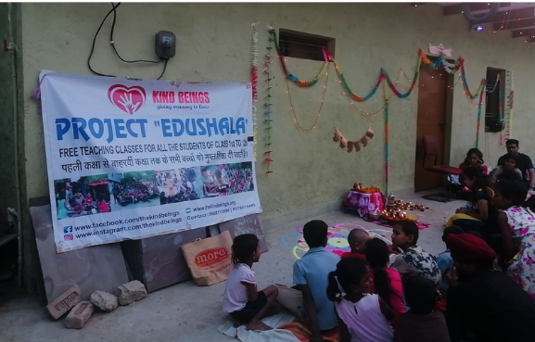We collaborate with several renowned organisations to accomplish our objective, including HCL, DELL, Young Indians, NDIM, FIENA, Those in Need, World Animal Protection, Amity University, and others.

Our connection to this globe is the thread of humanity. Therefore, we feel obligated to lend a helping hand to those attempting to stand on their own feet.

We Kind Beings believes in working for the betterment of the society and believes in spreading education to all, through this medium we would like to bring the youth together and would like to encourage them to work towards the betterment of the society.

**Kind Beings - Guide to Awareness**

**{KB-GTA}**

Welcome to "Kind Beings - Guide to Awareness"! Our non-profit organisation is committed to cultivating kindness, empathy, and awareness in our society. Our purpose is to inspire and empower individuals to make a difference in their communities and the world.

At Kind Beings, we believe that every act of kindness, no matter how small, can create a profound impact. We aim to foster a culture of compassion and understanding through our programs, initiatives, and collaborations. We organise workshops, seminars, and awareness campaigns that address pressing social issues, such as mental health, poverty, environmental sustainability, and equality.

We are dedicated to working with people of all ages and backgrounds, from schools and universities to community groups and corporations. By integrating kindness and empathy into educational curricula and promoting active participation in social causes, we strive to create a more inclusive and harmonious society.

Join us on this remarkable journey of spreading awareness, igniting compassion, and building a brighter future. Let's inspire kindness and create a world where every being is valued and respected.

+91 7834854514

**Note to Students**

Aanya and Shiv are your adventure buddies as you explore this exciting textbook. They love asking all sorts of questions and collecting them in their magical sacks.

Together, you'll search for answers through fun discussions, cool experiments, and amazing discoveries. You can even add your own awesome questions and share your findings from activities. Remember to make careful observations and enjoy the thrill of learning.

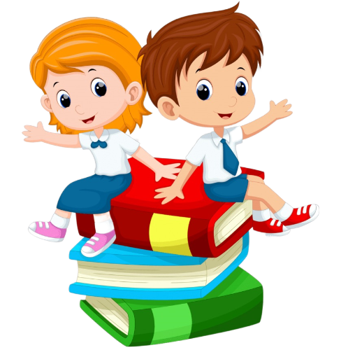Let's join Aanya and Shiv on this incredible journey of knowledge and uncover fascinating secrets hidden within the pages of this book!

**Aanya & Shiv**

**A Note to Teachers**

* **Create a Friendly Learning Environment:** Make your classroom a welcoming and respectful place where everyone feels comfortable participating in groups.
* **Set Clear Learning Goals:** Tell students what they will learn in each lesson or topic.
* **Interactive Teaching Methods:**  Use talking, group activities, videos, and hands-on projects to make learning interesting.
* **Encourage Thinking:** Ask students questions, evaluate information and discuss their thoughts respectfully to increase their logical thinking.
* **Reflect on Learning:**  Connect new ideas to things they already know and how it applies to their lives.
* **Involvement:** Give hands- on projects in groups.
* **Feedback:** Discuss progress, suggest improvements, praise, guide them.
* **Use Real-Life Examples:** Show practical applications. Help them see why it's important and how they can use it daily.
* **Support Different Needs:** Help students who learn in different ways or have different abilities. Give extra help when needed and offer resources for more learning or practice.
* **Inspire Love for Learning:** Let students see how fun and exciting learning can be and encourage them to keep learning after class.

**Table of Contents**

|  |  |  |
| --- | --- | --- |
| **S.no** | **Content** | **Pg No.** |
|  | Introduction | 9 |
|  | What is Menstruation? | 9 |
|  | Why does Menstruation occur? | 9 |
|  | Menstrual cycle | 10 |
|  | Signs of Menstruation | 10 |
|  | Managing Menstruation | 11 |
|  | Dealing with cramps | 12 |
|  | Maintaining good hygiene | 12 |
|  | Emotional well being | 13 |
|  | What to use that would come in budget other than sanitary napkins and that would also not harm the environment? | 14 |
|  | Dietary intake | 17 |
|  | Do’s and Don’t’s | 20 |
|  | What is Menarche? | 23 |
|  | What is Menopause? | 24 |
|  | Story for better understanding | 26 |
|  | Summary and learnings | 28 |
|  | Key words and definitions | 29 |
|  | Exercise: Menstruation and Menstrual hygiene | 32 |
|  | Practical/Project Homework | 35 |
|  | Note to Volunteers | 36 |

**Introduction**

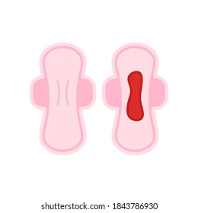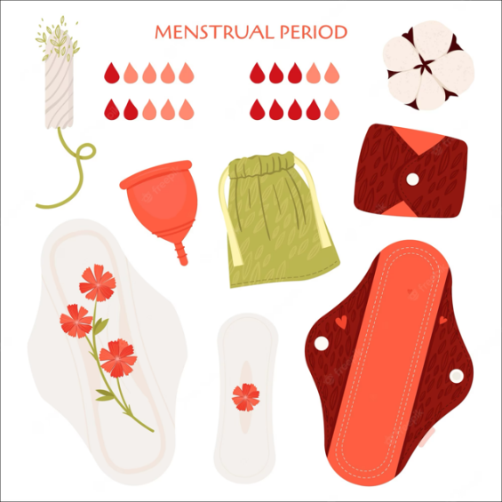

Menstruation is a natural process that happens to girls and women as they grow up. It is an important part of a girl's life and signifies her transition into womanhood. In this booklet, we will learn about menstruation, its purpose, how to manage it, and take care of our bodies during this time. Remember, menstruation is nothing to be ashamed of—it is a normal and healthy process!

**What is Menstruation?**

Menstruation is the monthly release of blood and tissue from a girl's uterus (womb). It happens when an egg is not fertilised by a sperm and the uterus sheds its lining. This process usually begins around the age of 10-15 years and continues until menopause, which is when a woman stops having her periods.

**Why does Menstruation occur?**

Menstruation is a sign that a girl's body is preparing for the possibility of pregnancy. Each month, the uterus prepares a soft and nourishing lining to support a fertilised egg. If pregnancy does not occur, the lining is shed through the vagina in the form of blood and tissue. This cycle repeats every month.

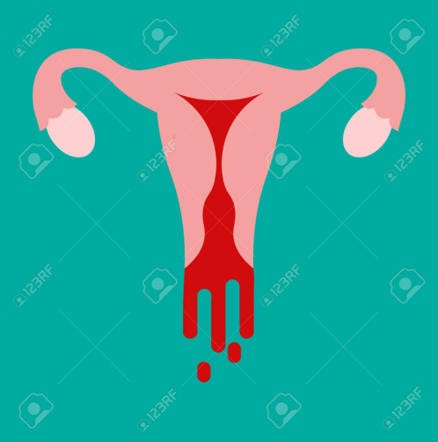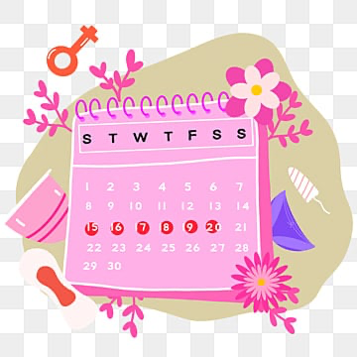

**Menstrual Cycle**

The menstrual cycle is the time between the start of one period and the beginning of the next. It usually lasts around 28 days, but it can vary from person to person. During this time, the body goes through different hormonal changes, which can cause physical and emotional changes.

.

**Signs of Menstruation**

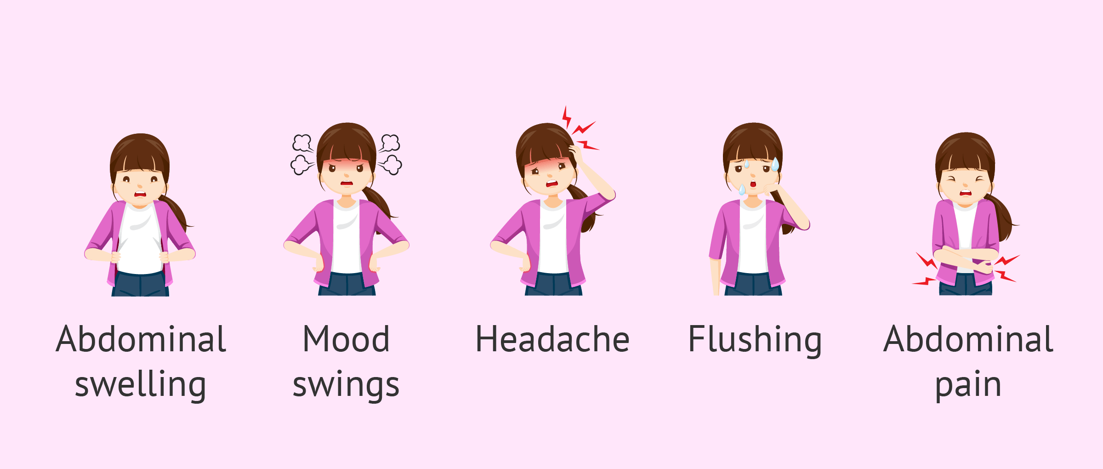

Before menstruation begins, you may notice some signs that your period is coming. These signs can include abdominal cramps, breast tenderness, mood swings, headaches, and bloating. It's normal to feel these changes, and they usually go away once your period starts.

**Managing Menstruation**

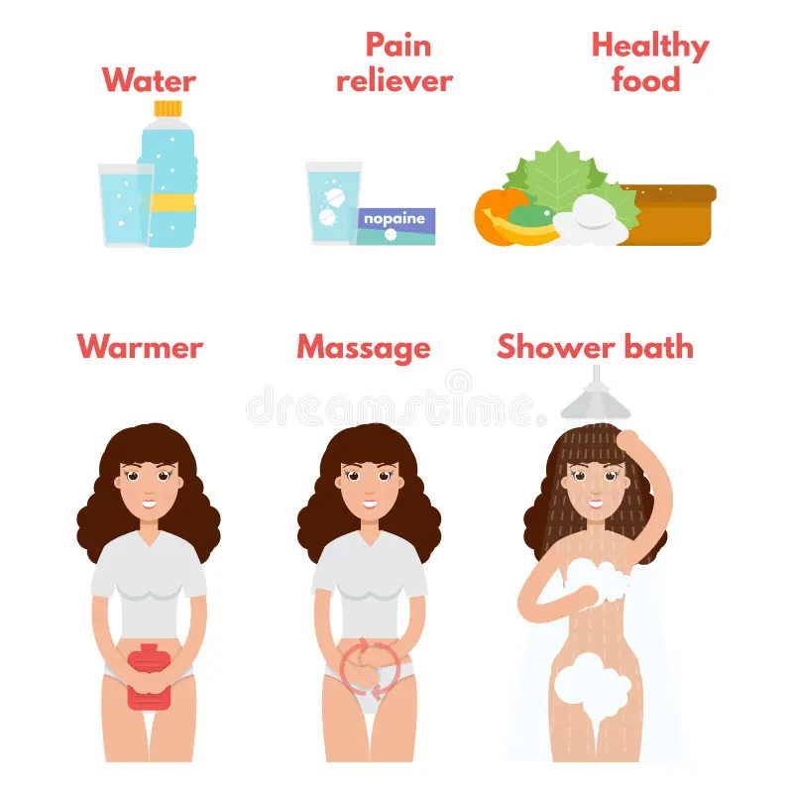

To manage menstruation, you will need some essential items:

* Menstrual pads or sanitary napkins: These are soft materials that absorb the blood. Change your pad every 4-6 hours to keep yourself clean and comfortable.
* Proper hygiene: Wash your hands before and after changing your pad to prevent infections.
* Disposal: Wrap used pads in a newspaper or plastic bag before throwing them away. Do not flush them in the toilet as it can cause blockages.

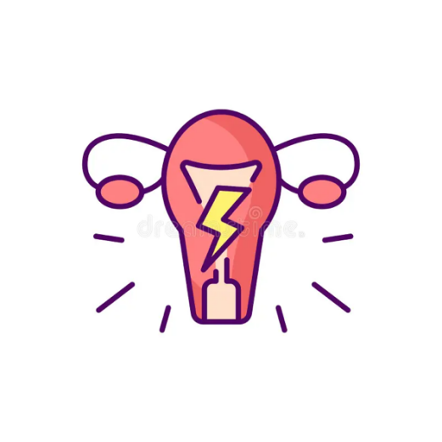**Dealing with cramps**

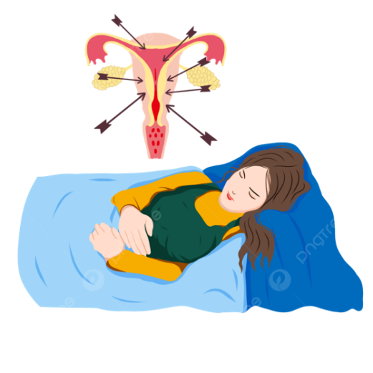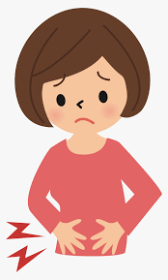Many girls experience cramps during their periods. To ease the discomfort, try the following:

* Place a hot water bottle or a warm cloth on your abdomen.
* Take rest and avoid strenuous activities.
* Drink warm liquids like warm water.

**Maintaining good hygiene**

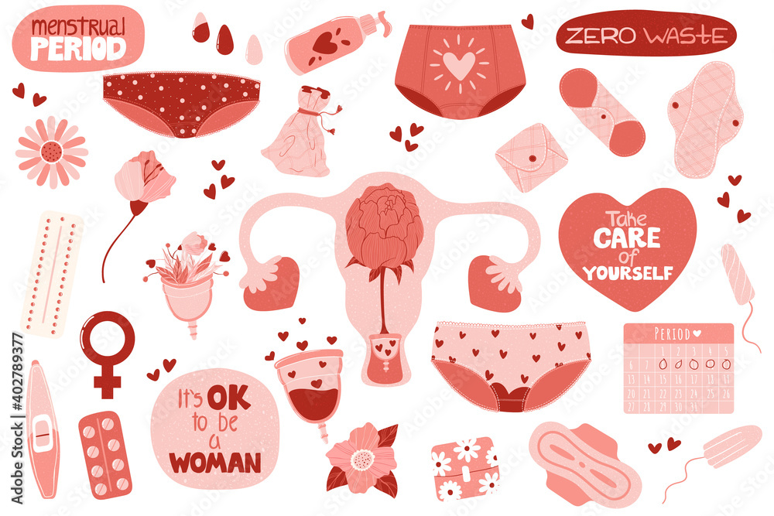

During your period, it's important to maintain good hygiene to prevent infections. Remember these hygiene tips:

* Change your pad regularly.
* Wash your genital area with clean water and mild soap.
* Pat dry your genital area gently after washing.
* Avoid using scented products as they can irritate the skin.

**Emotional well-being**

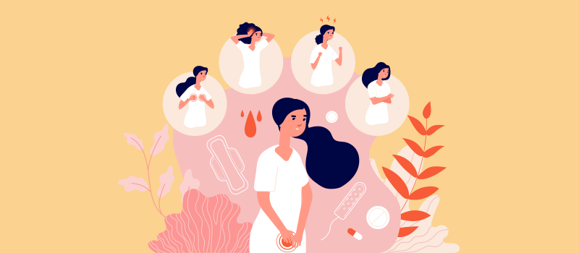

Some girls may feel moody or emotional during their periods. It's important to take care of your emotional well-being by:

* Talking to a trusted adult or friend if you feel sad or overwhelmed.
* Engaging in activities you enjoy, like reading, drawing, or listening to music.

**Conclusion**

Menstruation is a natural process that every girl experiences as she grows up. It's important to understand and embrace this part of life. Remember to take care of your body, manage your periods hygienically, and seek support if needed. Menstruation is a normal and healthy part of being a woman. Embrace it with pride!

**What to use that would come in budget other than sanitary napkins and that would also not harm the environment?**

Alternative Menstrual Products on a Budget:

1. **Reusable Cloth Pads:**

* Cloth pads can be washed and reused, making them a cost-effective option.
* can be made at home using soft, absorbent fabric or old cotton clothing.
* After use, rinse the cloth pad with water, wash it with soap, and dry it in the sun for reuse.

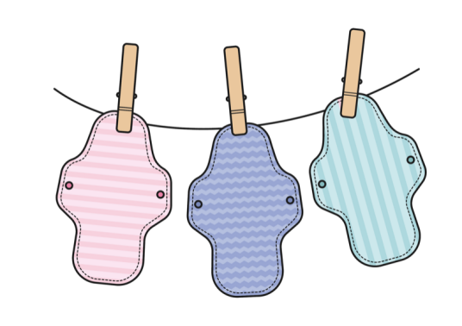

1. **Home-made Cloth Pads:**

* For those who cannot afford to buy cloth pads, home-made options are available.
* Old, clean cotton fabric or soft towels can be folded and used as makeshift pads.
* It is essential to wash and dry them properly after each use to maintain hygiene.

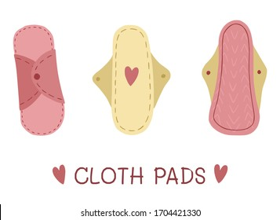

1. **Community Programs and NGOs:**

* Local organisations or NGOs may provide free or subsidised menstrual products to those in need.
* Government initiatives or community programs often distribute menstrual supplies to underprivileged communities.
* Students can inquire about such programs or approach local authorities for assistance.

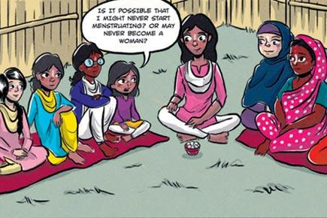

1. **Menstrual Product Exchanges:**

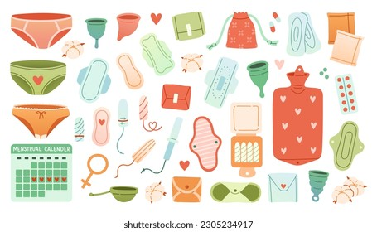

* Encourage girls to participate in menstrual product exchanges within their community.
* This involves sharing and swapping unused or lightly used products with others who may need them. It helps reduce costs and ensures that products are utilised effectively.

1. **Proper Hygiene Practices:**

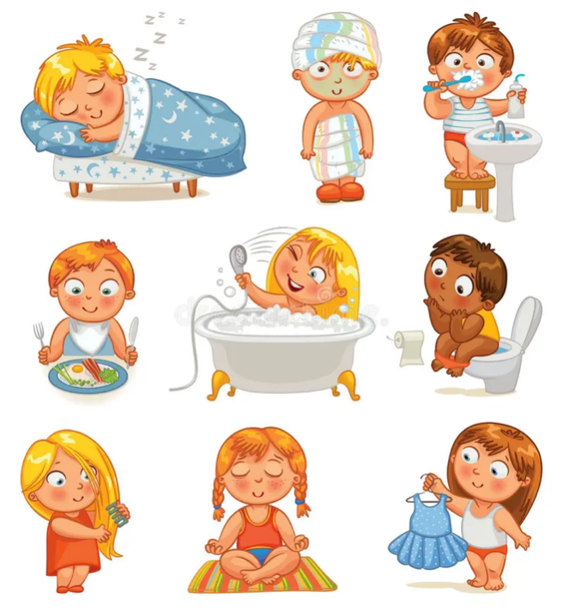

* Regardless of the menstrual product used, it is essential to maintain proper hygiene.
* Girls should wash their reusable products thoroughly with mild soap and clean water, ensuring they are dry before reuse.
* Regular hand-washing with soap and water is crucial before and after handling menstrual products.

1. 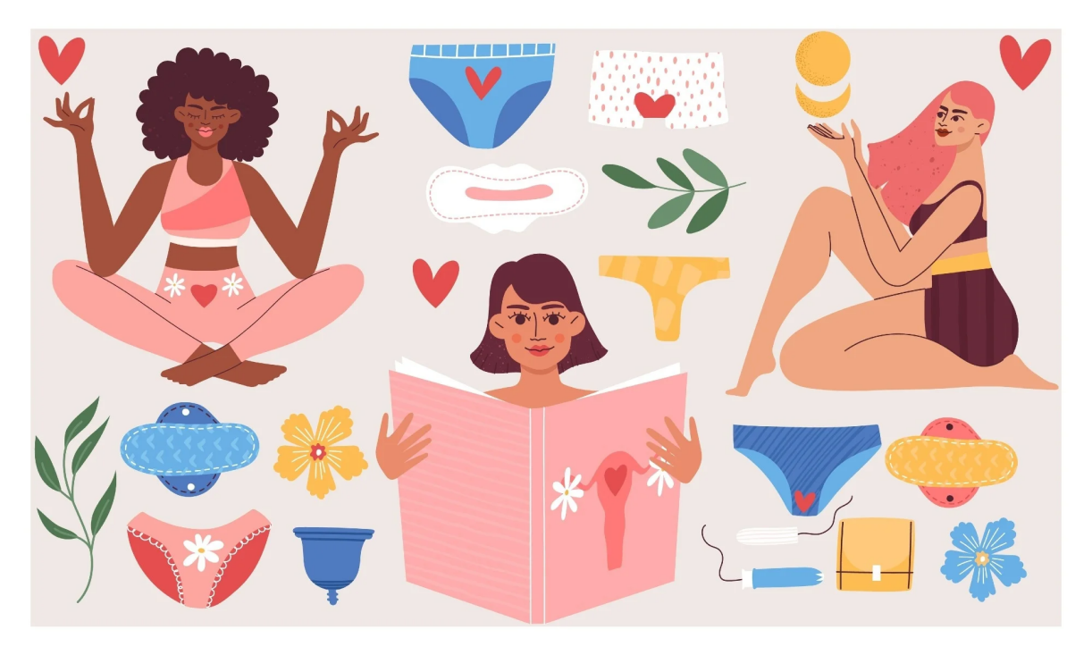**Menstrual Education:**

* Providing comprehensive menstrual education is vital to help girls understand their options and make informed choices.
* Teach them about the different menstrual products available, their usage, and proper hygiene practices.
* This empowers them to manage their periods effectively while considering their budget and the environment.

Remember, it's important to choose options that are accessible, affordable, and environmentally friendly while ensuring the comfort and well-being of the girls.

**Dietary intake**

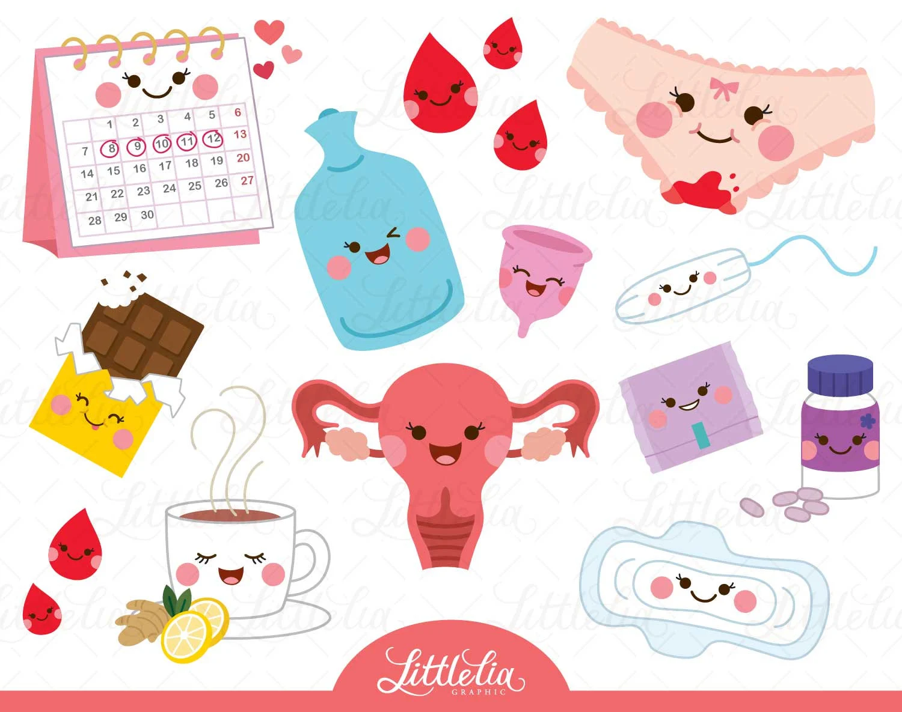

During menstruation, it is important to focus on maintaining a healthy diet to support your body's needs. Here are some easy pointers for dietary intake during menstruation:

1. **Stay Hydrated:**

* Drink plenty of water throughout the day to stay hydrated and help alleviate bloating.
* Include herbal teas, coconut water, or infused water for added hydration and flavour.

1. **Iron-Rich Foods:**

* Consume iron-rich foods to help replenish the iron lost during menstruation.
* Include foods like spinach, kale, lentils, beans, tofu, lean meats, and fortified cereals.

1. **Vitamin C:**

* Pair iron-rich foods with sources of vitamin C to enhance iron absorption.
* Include citrus fruits (oranges, lemons), berries, tomatoes, bell peppers, and broccoli.

1. **Calcium and Vitamin D:**

* Maintain healthy bone health by consuming calcium-rich foods.
* Include dairy products (milk, yogurt, cheese), leafy greens, almonds, and fortified plant-based milk.
* Get adequate sunlight exposure or consider vitamin D supplements if necessary.

1. **Healthy Fats:**

* Incorporate healthy fats into your diet for hormonal balance and overall well-being.
* Include foods like avocados, nuts, seeds, olive oil, fatty fish (salmon, mackerel), and coconut oil.

1. **Complex Carbohydrates:**

* Opt for complex carbohydrates that provide sustained energy and help manage mood swings.
* Include whole grains (oats, brown rice, quinoa), whole wheat bread, legumes, and starchy vegetables.

1. **Fresh Fruits and Vegetables:**

* Incorporate a variety of fresh fruits and vegetables into your meals and snacks.
* These provide essential vitamins, minerals, and fibre for overall health and digestion.

1. **Avoid Excessive Salt and Sugar:**

* Limit your intake of salty and sugary foods to help reduce bloating and water retention.
* Opt for natural sweeteners like honey or fresh fruits to satisfy sweet cravings.

1. **Listen to Your Body:**

* Pay attention to your body's cues and eat when you're hungry.
* Include small, frequent meals to maintain steady energy levels and avoid overeating.

1. **Self-Care:**

* Practice self-care during menstruation, such as getting enough rest, managing stress, and engaging in activities that bring you joy.

Remember, these are general guidelines, and individual nutritional needs may vary. It's always a good idea to consult a healthcare professional or nutritionist for personalised advice based on your specific requirements.

**Do’s during Menstruation Time:**

1. **Maintain Good Hygiene:**

* Change your menstrual products (pads, cups, or cloth pads) regularly to prevent infections.
* Wash your hands with soap and water before and after handling menstrual products.

1. **Stay Hydrated:**

* Drink plenty of water throughout the day to stay hydrated and maintain overall health.

1. **Eat Nutritious Foods:**

* Consume a balanced diet with iron-rich foods (leafy greens, lentils), fruits, vegetables, and whole grains to replenish nutrients lost during menstruation.

1. **Take Adequate Rest:**

* Get enough sleep and rest to support your body during this time.

1. **Manage Discomfort:**

* Apply a warm compress or use a heating pad on your lower abdomen to relieve menstrual cramps.
* Engage in light exercises or gentle stretching to alleviate discomfort.

1. **Practice Self-Care:**

* Engage in activities that help you relax and destress, such as reading, listening to music, or spending time with loved ones.

1. **Seek Support:**

* Talk to a trusted adult or friend if you have any concerns or questions about menstruation.

**Don’t’s during Menstruation Time:**

1. **Don't Neglect Personal Hygiene:**

* Avoid neglecting personal hygiene during menstruation. Maintain cleanliness by changing your menstrual products regularly and washing your genital area with clean water and mild soap.

1. **Don't Use Unsanitary Materials:**

* Avoid using unsanitary materials like old rags, newspapers, or plastic bags as makeshift menstrual products. These can cause infections and discomfort.

1. **Don't Skip Meals:**

* Avoid skipping meals as it can lead to low energy levels and nutrient deficiencies. Eat regular, balanced meals to support your overall health and well-being.

1. **Don't Engage in Strenuous Activities:**

* Avoid engaging in strenuous physical activities or heavy lifting during menstruation. Listen to your body and take it easy to prevent excessive fatigue and discomfort.

1. **Don't Ignore Signs of Infection:**

* If you experience persistent pain, foul odour, or unusual discharge, seek medical attention as these could be signs of infection.

1. **Don't Isolate Yourself:**

* Don't isolate yourself or feel ashamed about menstruation. It is a natural process that every girl goes through. Seek support from friends, family, or support groups to discuss your experiences and address any concerns.

In conclusion, menstruation is a natural process that girls and women experience as part of their reproductive health. It is important to understand menstruation, its purpose, and how to manage it effectively. By maintaining good hygiene, using appropriate menstrual products, and taking care of our bodies, we can navigate menstruation with confidence and comfort. It is crucial to embrace menstruation as a normal and healthy part of life and seek support when needed. Remember, every girl and woman deserves access to proper menstrual education, products, and support to ensure their well-being and dignity.

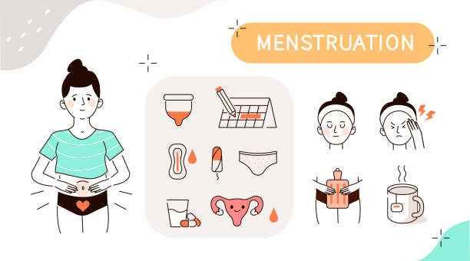

**What is Menarche?**

Menarche is the term used to describe a girl's first menstrual period, marking the beginning of her reproductive years. Here's a brief explanation of menarche in easy words with pointers:

1. **Definition:**

* Menarche is the special time when a girl has her first period, which means she can now become pregnant and have a baby.

1. **Age Range:**

* Menarche usually happens between the ages of 10 and 15, but it can vary for each girl. Some may start earlier, while others may start later.

1. **Physical Changes:**

* Menarche is a sign that a girl's body is growing and maturing into a woman's body.
* Along with the first period, there may be other physical changes like breast development and growth of pubic hair.

**4. Emotional Changes:**

* Menarche can bring about different emotions, such as excitement, confusion, or even some worry. These feelings are normal, and it's important to talk to a trusted adult or seek support if needed.

**5. Importance of Menarche:**

* Menarche is an important milestone as it signifies the beginning of a girl's fertility and ability to have children in the future.
* It is a natural and normal part of growing up and becoming a woman.

**6. Preparation:**

* It's helpful to be prepared for menarche by having knowledge about menstruation, understanding menstrual hygiene, and knowing what products to use during periods.
* Girls can learn about menstruation through educational materials, discussions, or workshops.

1. **Seeking Support:**

* It's important to have someone to talk to, such as a parent, older sibling, teacher, or school counsellor, who can provide guidance and answer any questions or concerns about menarche.

Remember, menarche is a significant and natural event in a girl's life. Understanding what it means and having the necessary support and knowledge can help girls navigate this transition with confidence and ease.

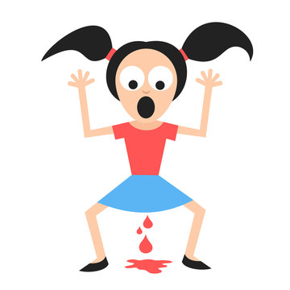

**What is Menopause?**

Menopause is a natural phase in a woman's life when she stops having menstrual periods. It typically occurs between the ages of 45 and 55, but the timing can vary for each individual. Menopause marks the end of a woman's reproductive years.

Here are some easy-to-understand pointers about menopause:

**1. Definition:**

* Menopause is a stage when a woman's ovaries stop releasing eggs and her hormone levels, including estrogen and progesterone, decrease.

1. **Symptoms:**

* Menopause can bring various symptoms, including hot flashes (sudden feelings of heat), night sweats, mood swings, vaginal dryness, irregular periods, sleep disturbances, and changes in the menstrual cycle.

1. **Pre menopause:**

* Before reaching menopause, women go through a transitional phase called perimenopause. During this time, hormone levels fluctuate, leading to irregular periods and menopausal symptoms.

1. **Duration:**

* Menopause is considered complete when a woman has not had a menstrual period for 12 consecutive months. After this period, she is considered post menopausal.

1. **Physical and Emotional Changes:**

* Menopause can bring physical changes such as weight gain, changes in skin and hair, and bone density loss. It can also affect emotions and mood, leading to feelings of sadness, irritability, or anxiety.

1. **Management of Symptoms:**

* Healthy lifestyle habits, such as regular exercise, a balanced diet, and stress management, can help alleviate menopausal symptoms.
* Hormone replacement therapy (HRT) may be prescribed by a doctor to relieve severe symptoms. However, this should be discussed with a healthcare professional.

1. **Importance of Self-Care:**

* It is crucial for women to take care of themselves during menopause. This includes practising good self-care, seeking support from friends and family, and talking to a healthcare professional about any concerns or questions.

1. **Post menopausal Health:**

* After menopause, women are at an increased risk for certain health conditions, such as osteoporosis (bone loss) and heart disease. Regular check-ups, screenings, and a healthy lifestyle can help maintain good overall health.

Remember, menopause is a natural part of a woman's life journey, and while it may bring some challenges, it also marks a new phase with opportunities for personal growth and well-being.

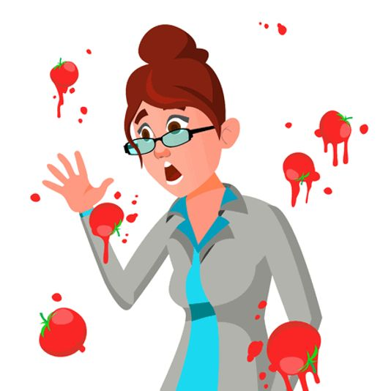

**A story for better understanding**

Once upon a time, in a bustling slum community, lived a young girl named Maya. Maya was a bright and curious girl who loved to learn and explore. However, she often felt confused and uncomfortable when her older sister, Rina, talked about something called "menstruation."

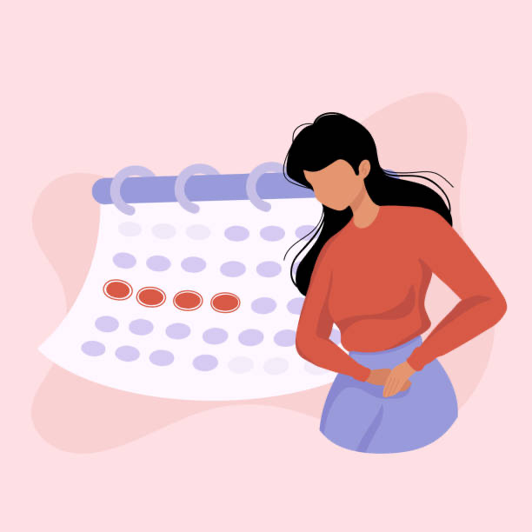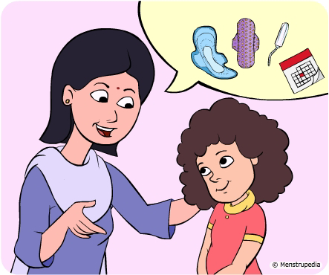One sunny day, Maya approached Rina, who had just finished reading a book. Maya gathered her courage and asked, "Rina, can you tell me what menstruation is? I've been hearing about it, but I don't really understand."

Rina smiled warmly at Maya and sat her down. She began to share a story to help Maya better understand what menstruation is all about.

"Maya, imagine our bodies as a beautiful garden," Rina said. "Every month, our garden prepares for the possibility of a new life to grow, just like planting seeds. Our uterus, which is like a cosy flower bed, creates a soft lining in case a tiny seed, called an egg, is fertilised by a sperm."

Maya's eyes widened with curiosity as she listened attentively. She imagined the garden in her mind.

"Now, if the egg is not fertilised, our body realises that the garden is not needed for a baby to grow," Rina continued. "So, just like when the seasons change and leaves fall from trees, our uterus sheds the soft lining it created. This shedding process is what we call menstruation."

Maya nodded, starting to grasp the concept. "So, it's like cleaning the garden to make it ready for the next possibility of a baby?"

Rina smiled, impressed by Maya's understanding. "Exactly, Maya! Menstruation is our body's way of preparing for new beginnings each month. It's completely natural and shows that our bodies are growing and changing."

Maya's confusion turned into curiosity and acceptance. She felt grateful to her sister for explaining menstruation in a way that made sense to her.

From that day on, Maya embraced menstruation as a normal part of life. She understood that it was nothing to be ashamed of, but rather a sign of womanhood and a reminder of the incredible power her body possessed.

Maya became an advocate for menstrual health in her community. She shared her knowledge with other girls, encouraging them to embrace their bodies and providing guidance on how to manage their periods safely and hygienically.

Together, Maya and her friends created a supportive environment where girls could openly discuss menstruation without fear or embarrassment. They organised workshops and collected reusable menstrual products to ensure that every girl had access to the resources they needed.

Maya's journey from confusion to empowerment showed her that knowledge is power. By understanding menstruation and supporting each other, the girls in the slum community blossomed into confident young women who celebrated their bodies and dreams.

And so, Maya's story became an inspiration for girls everywhere, reminding them that menstruation is a natural and beautiful part of life—a journey to be embraced with knowledge, pride, and unity.

**Summary/Learnings**

In summary, menstruation is a normal and natural process that girls and women go through as part of their reproductive health. It involves the monthly release of blood and tissue from the uterus. Here are the key points covered in easy words:

* Menstruation is when a girl or woman has her period, which means she can now have a baby.
* It usually starts between the ages of 10 and 15, but this can vary for each person.
* Menstruation is a sign that a girl's body is growing and becoming a woman's body.
* It can bring about different emotions, such as excitement or confusion, which is normal.
* Taking care of personal hygiene during menstruation is important to stay clean and healthy.
* Using proper menstrual products like pads, cups, or cloth pads is necessary to manage the flow.
* It's important to eat nutritious foods, stay hydrated, and get enough rest during menstruation.
* Seeking support from trusted adults or friends can help with any concerns or questions about menstruation.
* Menarche, which is the first menstrual period, marks the beginning of a girl's ability to have children.

Remember, menstruation is a natural part of growing up, and every girl deserves access to education, support, and resources to manage it comfortably and with dignity.

**Glossary:**

* **Fertility:**

The ability to have babies or become pregnant.

* **Maturing:**

The process of growing and developing into an adult.

* **Pubic hair:**

The hair that grows around the genital area during puberty.

* **Milestone:**

A significant event or achievement that marks an important stage or point in someone's life.

* **Menstrual hygiene:**

The cleanliness practices and care taken during menstruation to keep oneself healthy and comfortable.

* **Fertilisation:**

The process where an egg and sperm join together to start a pregnancy.

* **Transition:**

The process of changing from one state, condition, or stage to another.

* **Concerns:**

Worries or things that cause someone to feel anxious or troubled.

* **Uterus:**

The uterus is a special part of a girl's body where a baby grows when a woman becomes pregnant.

* **Reproductive:**

Relating to the body's ability to produce offspring or have children.

* **Hormones:**

Chemical substances in the body that control various processes and functions, such as growth and development.

* **Ovulation:**

The release of an egg from the ovary, which typically happens once during each menstrual cycle.

* **Ovary:**

A part of the female reproductive system that produces eggs (ova) and female hormones.

* **Fallopian tubes:**

Tubes in the female reproductive system that connect the ovaries to the uterus and serve as a pathway for the egg to travel from the ovary to the uterus.

* **Menstrual flow:**

The blood and tissue that are discharged from the uterus during menstruation.

* **Menstrual products:**

Items like pads, tampons, or menstrual cups that are used to collect or absorb menstrual flow.

* **Endometrium**:

The lining of the uterus that thickens each month in preparation for pregnancy and sheds during menstruation if pregnancy does not occur.

* **Gynecologist:**

A doctor who specializes in women's reproductive health, including the female reproductive system and related disorders.

* **Endocrinologist:**

A doctor who specializes in the study of hormones and their impact on the body's functions.

* **Progesterone:**

A hormone produced in the female body that plays a role in regulating the menstrual cycle and preparing the uterus for pregnancy.

* **Contraception:**

Methods or devices used to prevent pregnancy, such as birth control pills, condoms, or intrauterine devices (IUDs).

* **Ovum:**

A mature egg cell that can potentially be fertilized by sperm.

* **Cervix:**

The lower part of the uterus that connects to the vagina.

* **PMS (Premenstrual Syndrome):**

A combination of physical and emotional symptoms that some people experience before the start of their menstrual period.

* **Estrogen:**

A hormone responsible for the development and regulation of the female reproductive system and secondary sexual characteristics.

* **Infertility:**

The inability to conceive or carry a pregnancy to full term despite regular unprotected sexual intercourse.

**Exercise: Menstruation and Menstrual Health**

**Instructions: Answer the following questions to test your understanding of menstruation, its dietary intake, dos and don'ts, the menstrual cycle, and signs of menstruation. Choose the correct option for each question.**

1. What is menstruation?

   a) The release of an egg from the ovaries

   b) The shedding of the uterine lining through vaginal bleeding

   c) The process of fertilization of an egg by sperm

**Answers:**

**1. b) The shedding of the uterine lining through vaginal bleeding**

__________________________________________________________________

2. Why is it important to maintain good hygiene during menstruation?

   a) To prevent infections

   b) To regulate the menstrual cycle

   c) To increase fertility

**Answers:**

**2. a) To prevent infections**

__________________________________________________________________

3. Which of the following is NOT a recommended menstrual product?

   a) Menstrual cup

   b) Sanitary napkin

   c) Plastic bags or newspapers

**Answers:**

**3. c) Plastic bags or newspapers**

__________________________________________________________________

4. What dietary nutrients are important during menstruation?

   a) Carbohydrates and fats

   b) Iron, calcium, and vitamin D

   c) Sugary foods and drinks

**Answers:**

**4. b) Iron, calcium, and vitamin D**

__________________________________________________________________

5. What are the dos during menstruation?

   a) Use unsanitary materials and isolate yourself

   b) Skip meals and engage in strenuous activities

   c) Maintain good hygiene, eat nutritious foods, and seek support

**Answers:**

**5. c) Maintain good hygiene, eat nutritious foods, and seek support**

__________________________________________________________________

6. What is the menstrual cycle?

   a) The time between periods

   b) The time between ovulation and fertilization

   c) The time between menstruation and menopause

**Answers:**

**6. a) The time between periods**

__________________________________________________________________

7. What are common signs of menstruation?

   a) All of these

   b) Headaches, back pain, and fever

   c) Increased energy levels and decreased appetite

   d) Abdominal cramps, breast tenderness, and mood swings

**Answers:**

**7. d) Abdominal cramps, breast tenderness, and mood swings**

8. What is menarche?

   a) The first occurrence of menstruation

   b) The end of the reproductive years

   c) The time between menstrual cycles

**Answers:**

**8. a) The first occurrence of menstruation**

__________________________________________________________________

9. Why is it important to educate and support girls about menstruation?

   a) To make them feel ashamed and embarrassed

   b) To promote menstrual hygiene and well-being

   c) To discourage conversations about reproductive health

**Answers:**

**9. b) To promote menstrual hygiene and well-being**

__________________________________________________________________

10. True or False: Menopause marks the end of fertility in women.

    a) True

    b) False

**Answers:**

**10. a) True**

__________________________________________________________________

**Practical/Project Homework**

Making of home-made cloth pads for students for their own use

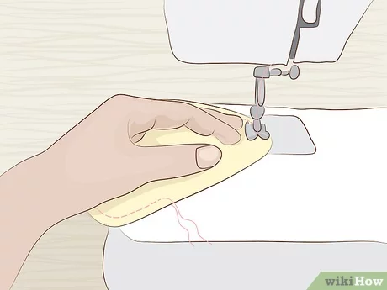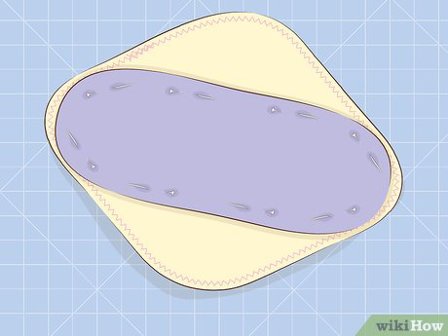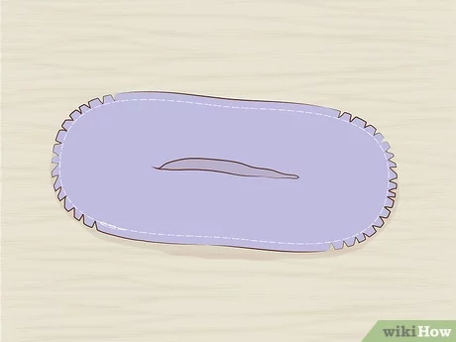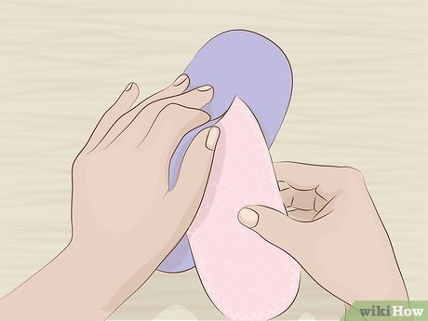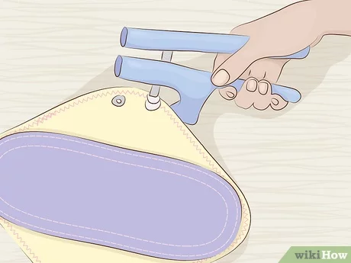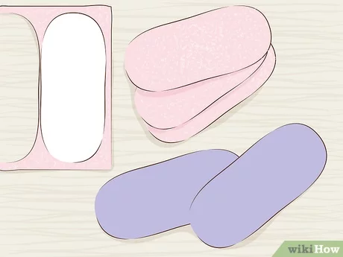

**Note for Volunteers**

Making home-made cloth pads can be a cost-effective and environmentally friendly option for managing menstruation. Here are instructions on how to make them, along with the materials required:

**Materials Required:**

1. Absorbent fabric (e.g., cotton flannel or terry cloth) for the main pad layers

2. Soft fabric (e.g., cotton or fleece) for the top layer that touches the skin

3. Snaps or Velcro for securing the pad

4. Thread

5. Sewing machine or needle for hand sewing

6. Scissors

7. Pins or clips to hold the fabric in place during sewing

8. Water-resistant or leak-proof fabric (optional) for the bottom layer

9. A template or pattern for the desired pad shape and size

**Instructions:**

1. Wash and sanitize the fabric before starting to ensure cleanliness.
2. Use a template or create your own pattern for the pad shape and size. You can make different sizes to suit your needs.
3. Cut the absorbent fabric, soft fabric, and water-resistant fabric (if using) according to the pattern.
4. Layer the fabric pieces together, with the absorbent fabric in the middle, soft fabric on top, and water-resistant fabric (if using) at the bottom.
5. Pin or clip the layers together to keep them in place.
6. Sew around the edges of the pad, leaving a small opening to turn it inside out.
7. Trim any excess fabric and carefully turn the pad inside out through the opening.
8. Use a needle and thread or a sewing machine to close the opening.
9. Attach snaps or Velcro to the wings of the pad for securing it around underwear.

10. Repeat the process to create multiple pads for a complete set.

Remember to wash and dry the cloth pads thoroughly after each use. They can be hand washed or machine washed, depending on the fabric used. It's important to maintain good hygiene by changing the cloth pads regularly and drying them in sunlight to ensure they are clean and ready for reuse.

**Note: It may be helpful to provide additional instructions or demonstrations to slum students who may not be familiar with sewing or using cloth pads.**